Robot Build and

Installation Instructions

By: Jim Schrempp and Bob Glicksman; v1, 9/14/2020

**NOTICE:** Use of this document is subject to the terms of use described in the document “Terms_of_Use_License_and_Disclaimer” that is included in this release package. This document can be found at:

https://github.com/TeamPracticalProjects/Robotics/blob/master/Terms_of_Use_License_and_Disclaimer.pdf

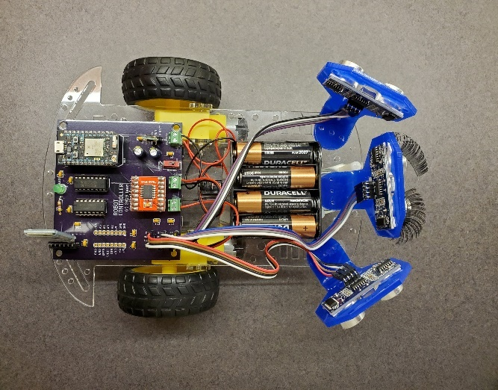

© 2020 Team Practical Projects, Bob Glicksman and Jim Schrempp. All rights reserved.

# 

# 

# 

# TABLE OF CONTENTS.

TABLE OF CONTENTS. 1

1. OVERVIEW. 2

2. ROBOT PCB ASSEMBLY INSTRUCTIONS. 4

3. ROBOT ASSEMBLY INSTRUCTIONS. 13

3.1. Robot Chassis. 14

3.2. Robot Wiring. 16

3.3. Power Up Testing. 20

4. FIRMWARE INSTALLATION INSTRUCTIONS. 21

5. ROBOT APP INSTALLATION INSTRUCTIONS. 23

# OVERVIEW.

This document provides step-by-step instructions for assembling and installing the Robot hardware, firmware and app software. Before proceeding with this project, you must read and accept the “*Terms_of_Use_License_and_Disclaimer*” document which is located in the root level of this repository.

The parts needed to build this project are illustrated in figure 1-1 and are described below:

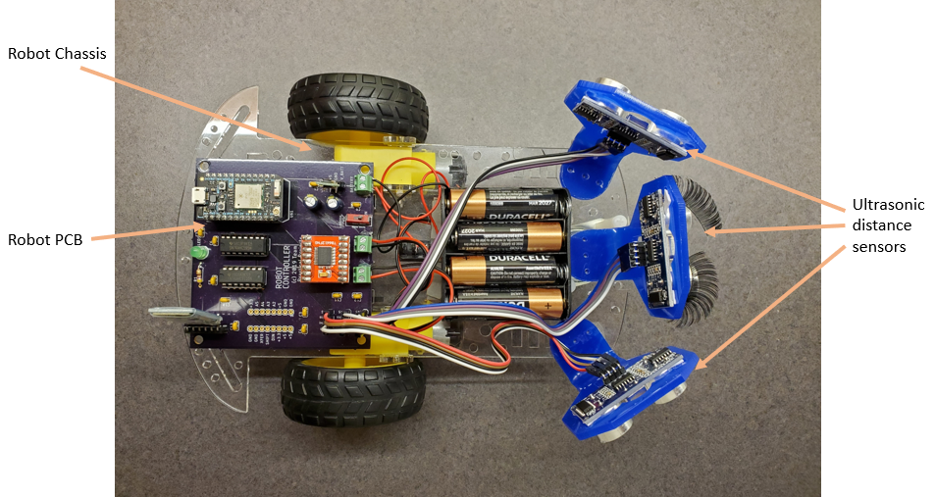

*Figure 1-1. Complete Robot Assembly.*

* Robot PCB: assembled printed circuit board with electronics to control the Robot. Section 2 of this document contains the details.
* Robot Chassis: this is a kit that must be assembled according to the instructions in section 3 of this document.
* Ultrasonic Sensors (SR-HC04). The Robot navigates based upon data from three ultrasonic distance sensors. These sensors are mounted on the Robot chassis using commercially available mounting brackets; see section 3 of this document for details.
* Batteries: The Robot is powered by 4 – AA batteries. The Robot kit contains the necessary battery holder.

The following tools and materials are needed to build this project. *Make sure that you know how to use these before undertaking this project*!

* Small tip soldering iron.
* Electrical solder.
* A few feet of #26 solid, insulated wire. It will be helpful to use three different colors – red, black, any other color.
* Female-female jumper cables, 9” long.
* Wire stripper.
* Diagonal wire cutter.
* Needle nose pliers.
* Various screwdrivers.
* Electrical tape.
* Hot glue gun with glue sticks or double sided tape (for mounting)

Our recommended order of assembly is as follows.

1. Assemble the Robot PCB with the necessary components for this project – see section 2 of this document.
2. Assemble and wire the Robot chassis from the kit – see section 3 of this document.
3. Mount the ultrasonic distance sensors and Robot PCB on the Robot chassis - see section 3 of this document.
4. Wire up the power, sensors, and Robot motors to the Robot PCB – see section 3 of this document.
5. Install Photon firmware – see section 4 of this document.
6. Install the App on your smartphone – see section 5 of this document.

# ROBOT PCB ASSEMBLY INSTRUCTIONS.

The Robot PCBcontains all of the electronics needed to control the Robot, except for the power on/off switch, the ultrasonic distance sensors, and the batteries. This section contains step-by-step instructions for assembling the Robot PCB.

Figure 2-1 shows the blank PCB. This is the top side of the board – the side where all of the components are mounted. All soldering is performed on the bottom side of the PCB.

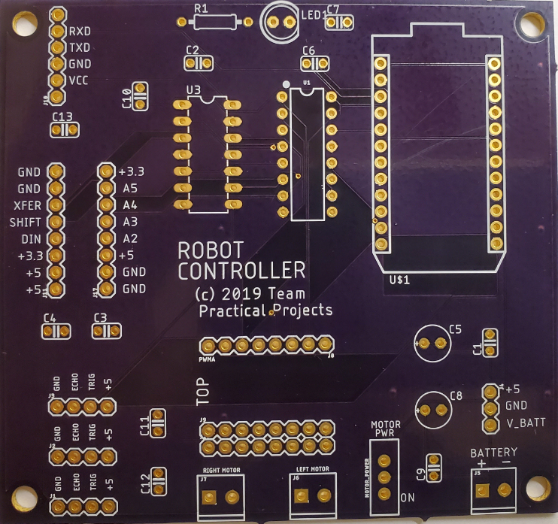

*Figure 2-1. Blank Robot PCB.*

We recommend that the board be assembled according to the height of the component, shortest components first. This is because it may be necessary to hold some of the components on the PCB with electrical tape while soldering and we don’t want tall components to get in the way.

The first step is to place 11 ea. 0.1 uF decoupling capacitors onto the component side of the PCB with the leads sticking through the holes in the board – see figure 2-2. Bend the leads over on the bottom of the PCB to hold these capacitors in place. Solder the capacitor leads to the PCB and clip the excess leads off with a diagonal cutter.

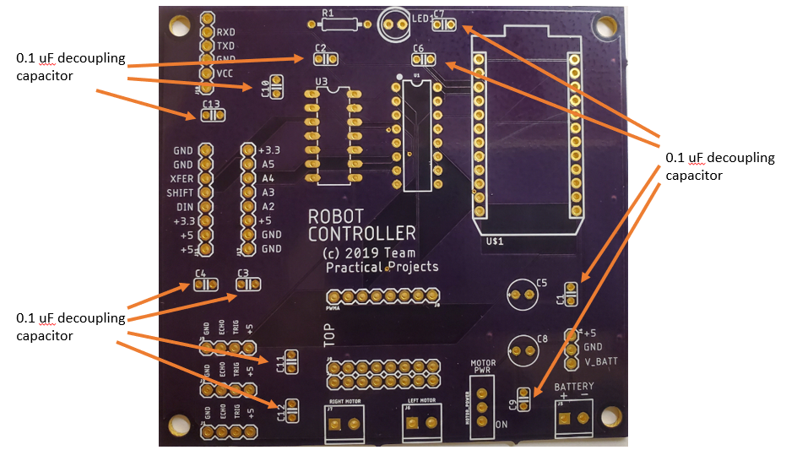

*Figure 2-2. Decoupling Capacitors*.

The next set of components to be soldered onto the PCB are shown is figure 2-3. Place the 14 pin DIP socket on the PCB where shown (U3). Make sure that the little notch on the socket aligns with the notch shown on the PCB silkscreen. Hold the socket fast to the PCB with electrical tape. Invert the board and solder two diagonally opposite pins first to hold the socket in place. The solder the remaining pins to the PCB. Next, repeat this process for the 16 pin DIP socket (U1).

Place three, 2-position terminal blocks on the PCB with the wire holes facing the outside of the PCB. Hold each of these terminal blocks, in turn, to the PCB using some electrical tape. Note that the terminal blocks can wiggle a little in the PCB holds. Try and align each terminal block to face straight outward before inverting the PCB and soldering the pins to the bottom of the PCB.

Place the PCB slide switch on the PCB in the area indicated as “MOTOR PWR”. Hold it fast to the PCB with electrical tape; invert the PCB and solder the leads to the bottom of the board.

Place the 470 ohm resistor on the PCB in the place marked R1. Bend the leads over on the bottom of the PCB to hold the resistor in place. Solder the leads and clip off the excess with a diagonal cutter.

Lastly, place the LED where indicated on the PCB. CAREFULLY note the flat part of the outline on the top of the PCB. Make sure that the flat part of the LED algins with the marking on the PCB. Bend the LED leads over to hold it in place and double check the LED placement. Then solder the leads to the bottom side of the PCB and clip off the excess with a diagonal cutter.

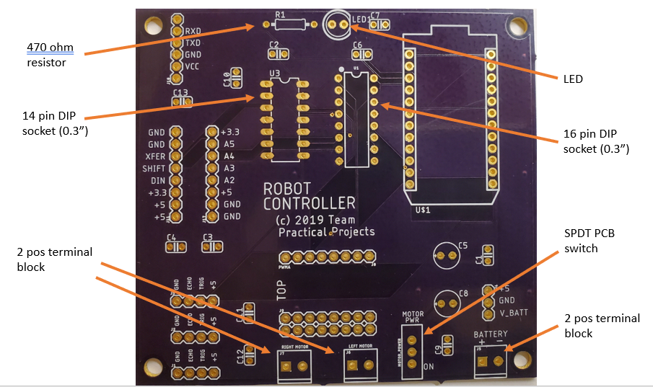

*Figure 2-3. LED/Resistor, DIP sockets, Switch, Terminal Blocks.*

The next step is to solder the female headers to the PCB; refer to figure 2-4. Begin with the 6 pin female header for the Bluetooth module shown in the upper left of figure 2-4. Place the header through the PCB and hold it in place with some electrical tape. Try and tape the header down so that it is vertical on the PCB. After aligning and taping the header to the PCB, invert the board and solder the two end pins to hold it in place. The solder the remaining pins.

Next, solder in the 3 pin female header for the voltage regulator. This is the header shown at the bottom right side of figure 2-4. Place the header through the PCB and hold it in place with some electrical tape. Try and tape the header down so that it is vertical on the PCB. After aligning and taping the header to the PCB, invert the board and solder the three pins to the PCB.

The next step is to solder the headers for the motor controller to the PCB. Two sets of 8-pin female headers are used. Note that three sets of headers are provided for on the PCB. The PCB supports two different modules that use the TB6612FNG duel motor controller chip. The modules differ only in the module width – one is 0.5” wide and the other is 0.6” wide. You do not need to worry about this as the headers will be soldered with your motor controller module in place. However, do make note that there will be an extra row of headers that are not soldered when your motor controller assembly is complete. This is normal and of no concern.

Solder male pins to the motor controller board so that the main components of the motor control board are facing upward (away from the pins); refer for figure 2-9 for example. Now place two 8-pin female headers into the pins on the bottom of your motor control module. The module orientation does not matter at this point as this assembly step is only needed to align the female pin headers when soldering them to the PCB. Now place the motor controller female headers down through the PCB and use some electrical tape to hold the motor controller and its female headers fast to the PCB. Invert the PCB and solder the 4 end pins (two on each female header) to hold the headers in place. Carefully, unplug the motor controller module from the female headers and set it aside. Now, solder the rest of the female header pins to the PCB.

The next step is to solder the headers for the Particle Photon to the PCB. Two sets of 12-pin female headers are used. Place the two 12-pin female headers into the pins on the bottom of The Photon. The Photon orientation does not matter at this point as this assembly step is only needed to align the female pin headers when soldering them to the PCB. Now place the Photon female headers down through the PCB and use some electrical tape to hold the Photon and its female headers fast to the PCB. Invert the PCB and solder the 4 end pins (two on each female header) to hold the headers in place. Carefully, unplug the Photon from the female headers and set it aside. Now, solder the rest of the female header pins to the PCB.

Lastly, place two 100uF filter capacitors through the holes for C5 and C8 on the PCB, as indicated in figure 2-4. Note that these capacitors are polarized and must be inserted in the correct orientation. The capacitors have a silver strip down one side – this is the minus (-) terminal of the capacitor. The PCB indicated the positive (+) lead with a little “+” sign. The capacitor lead that is NOT where the silver strip is goes on the hold marked “+”. The lead by the silver stripe goes through the unmarked hole on the PCB. In other words, the silver stripe on the C5 capacitor should be facing the C1 decoupling capacitor, and the silver stripe on the C8 capacitor should be facing the 3 pin female socket for the voltage regulator. Bend the leads over on the bottom of the PCB to hold the capacitors in place and double check the mounting polarity. Now, solder the leads to the bottom side of the PCB and clip off the excess leads with a diagonal cutter.

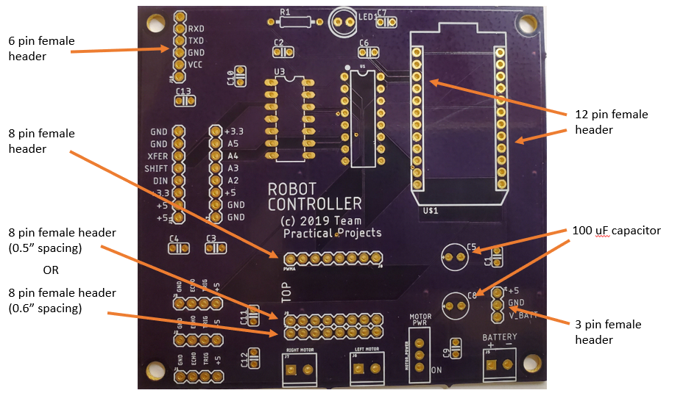

*Figure 2-4. Filter Capacitors, Female headers.*

The last soldering step involves soldering make pin headers to the PCB; see figure 2-5. The male pin headers come in a long strip and you use a pair of needle nose pliers to break off the number of pins that you need for each pin header connector. You will need three, 4-pin headers for this step. *Note that the PCB has two additional fields for 8-pin male pin headers. These are provided for possible future expansion of the electronics and you do not have to solder these optional pin headers onto the PCB at this time.* We recommend that you solder on only the three, 4-pin headers.

We suggest that you insert and solder one of these 4-pin headers to the PCB at a time. Break off the pin header and place it through the holes on the PCB. Use electrical tape to hold the pin header to the PCB for soldering. NOTE: try and tape the headers to the PCB so that they are vertical. This is tricky to do but it will make the board a lot neater if you are careful with this step!

After taping each 4-pin male header to the PCB, invert the board and solder the two end pins first. Then solder the two middle pins. Repeat this process for the remining two 4-pin headers.

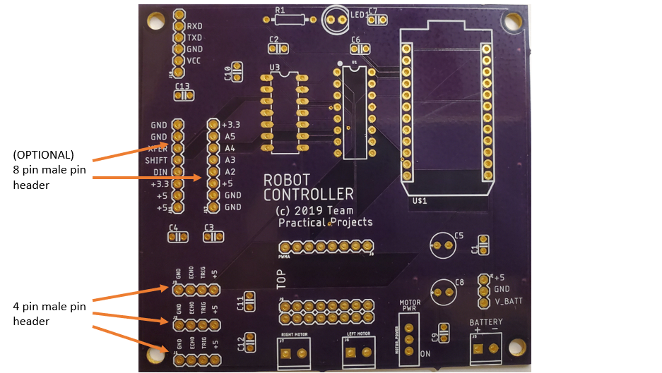

*Figure 2-5. Male Pin Headers.*

Congratulations! You have completed soldering components to the PCB. Carefully inspect all solder joins to ensure that there are no cold solder joints and no solder shorts on the bottom of the board. Clean off excess solder from the bottom of the board and inspect carefully one more time.

All that remains is to insert the socket components into their sockets on the PCB. Insert the Photon onto the PCB with the USB connector facing off of the board – see figure 2-6.

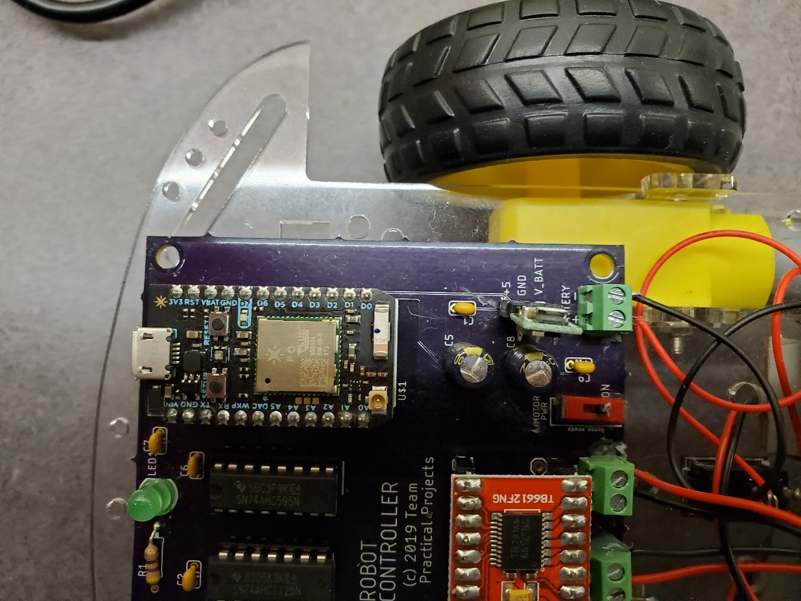

*Figure 2.6. Positioning the Photon.*

Next, plug the HC-05 bluetooth module into its 6-pin socket with the component side facing out from the board; i.e. the writing side facing onto the board – see figure 2-7.

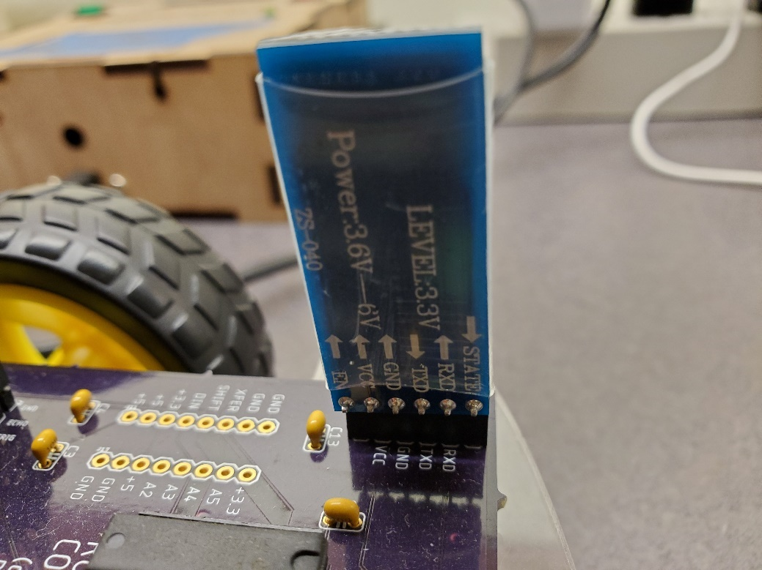

*Figure 2-7. Positioning the Bluetooth Module.*

You may need to solder pins into the Pololu voltage regulator module. Solder the right angle pin header onto the module so that the connector is on the side of the module as shown in figure 2-8 and solder the connector to the reverse side of the module. After soldering pins to the voltage regulator module, plug it into the 3 pin female header on the PCBN as shown in figure 2-8. Double check that this module is inserted into the header in the proper orientation.

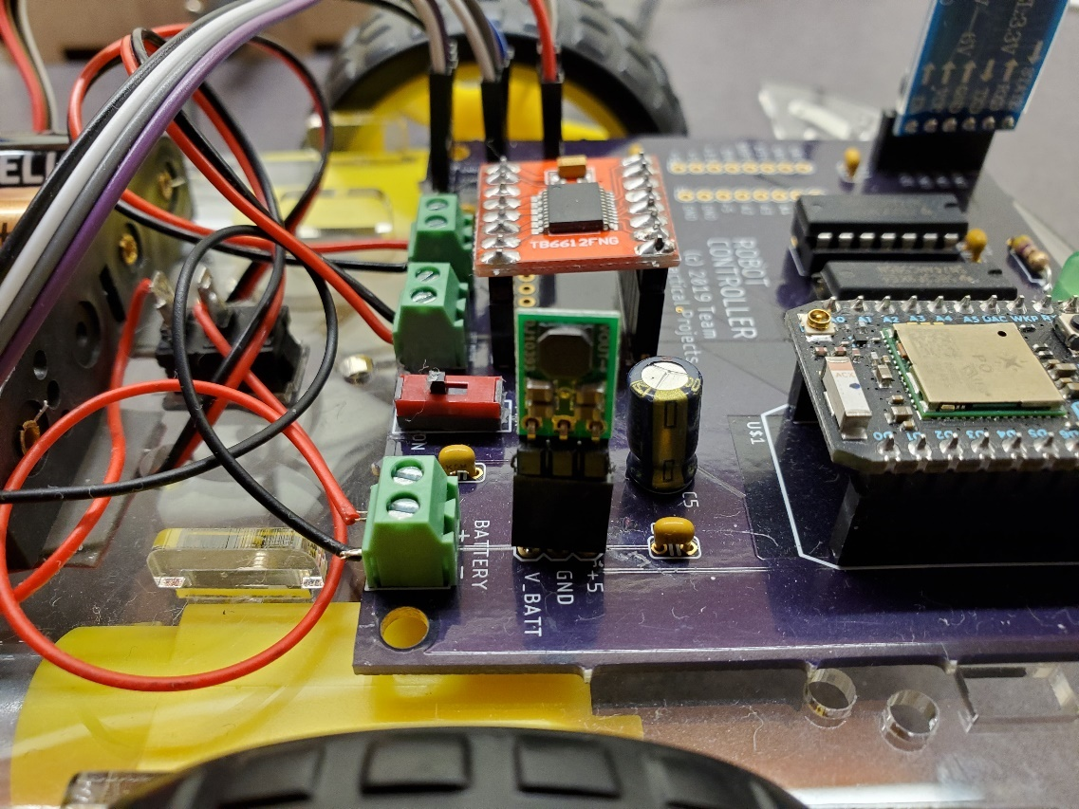

*Figure 2-8. Positioning the Voltage Regulator.*

Plug the motor controller module onto the PCB as shown in figure 2-9. Double check to ensure that the module is oriented exactly as shown in figure 2-9.

Plug the 74AHCT125 IC into the 14 pin DIP socket on the PCB. Make sure that the notch or dot on the IC faces where the notch on the socket is and ensure that all pins of the IC are properly inserted into the socket and not bent under the IC. Double check the orientation as in figure 2-9. Lastly, plug the 74HCT595 IC into the 16 pin DIP socket on the PCB. Make sure that the notch or dot on the IC faces where the notch on the socket is and ensure that all pins of the IC are properly inserted into the socket and not bent under the IC. Double check the orientation as in figure 2-9.

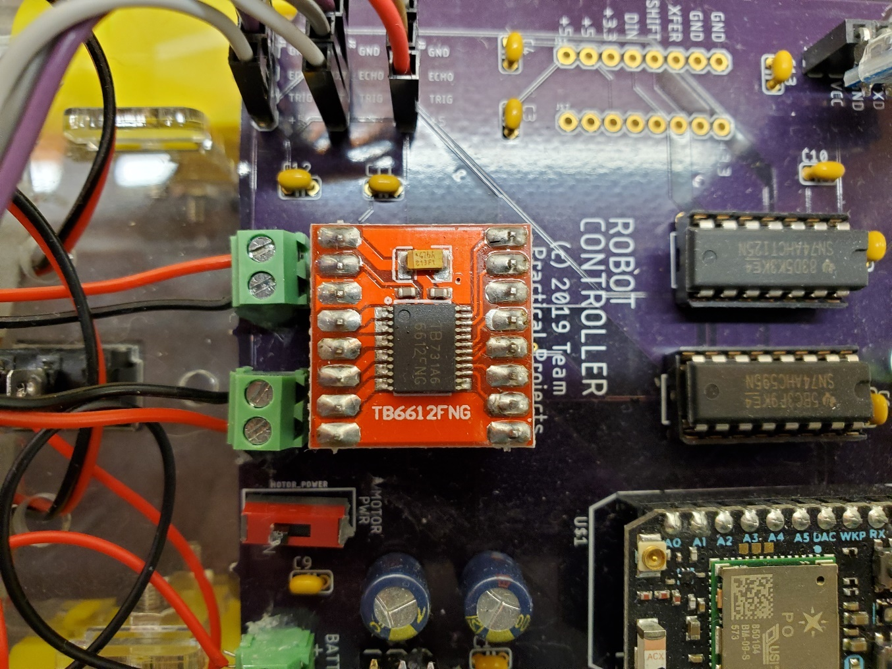

*Figure 2-9. Positioning the Motor Controller and Socketed ICs.*

The PCB assembly is now complete!

# ROBOT ASSEMBLY INSTRUCTIONS.

This section provides detailed instructions for assembling and wiring the Robot. The first step is assembling the Robot chassis from the Robot kit that you purchased. The battery holder, ultrasonic distance sensors and the Robot PCB are added. These components are then wired up to complete the Robot assembly.

## Robot Chassis.

Your Robot chassis kit should have come with assembly instructions. We have posted a copy of the instructions that came with our Robot in the file “MFG_robot_assembly_instructions.pdf” in this folder. The text is in Chinese, but the pictures should be self-explanatory. When assembling the Robot chassis, you may skip the step of attaching the front caster wheel as you will replace this with the ball caster wheel anyway.

We strongly recommend that you solder wires to the Robot motors before attaching the motors to the chassis. We recommend that you use #26 solid copper wire for these connections. Take care, as the terminals on the motors are rather delicate. You may want to use different color wires for the terminals on the motors to help you decide which wire goes to which terminal on the PCB’s motor terminal blocks. However, you will be testing for proper motor wiring when the assembly is finished and you can always reverse the motor wires if necessary. The motor control wires are not polarized, but they do determine which way the motor spins when commanded to do so by the Photon’s firmware. If in testing, a motor spins backward from the way it should spin, you can simple reverser the motor wires in the terminal block in the PCB to correct the problem.

Next, assemble the ball caster to the front of the Robot chassis. Figure 3-1 shows the assembly of the ball caster.

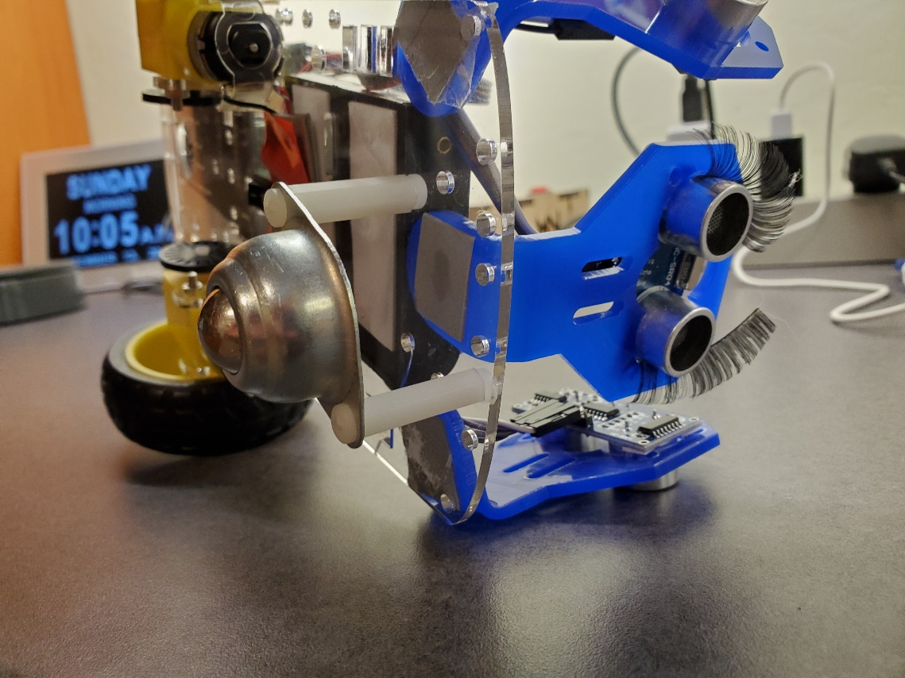

*Figure 3-1. Front Wheel Assembly using Ball Caster.*

Attach two, 1” threaded female-female standoffs of the ears of the ball caster using #6 screws. Do not tighten the screws at this point. Align the standoffs with two diagonally facing screw holes in the chassis that are intended for the kit’s caster wheel. Use two #6 screws to affix the standoffs to the chassis. Tighten all of the screws to complete the caster wheel assembly step.

Figure 3-2 shows the completed assembly of the Robot. To complete Robot assembly, you will be adding the power switch, the battery holder, the PCB and the three ultrasonic sensors to the chassis.

**

*Figure 3-2. Completed Robot Assembly.*

First, make sure that you have pressed the power switch that comes with the Robot kit into the hole provided in the chassis. You should have done this when assembling the robot chassis per the kit instructions. We suggest that you mount this switch upside down – i.e. with the switch control on the Robot’s underside and the switch terminals on the top side of the Robot chassis. This will make power wiring a little easier; however, either way that you mount the switch will work.

Next, place the battery holder in the top of the robot chassis approximately where shown in figure 3-2. Use double sided tape or hot glue to affix the battery holder to the Robot chassis. Make sure that the battery wires face the rear of the Robot (i.e. face the power switch and the PCB).

Next, place the Robot PCB (that you assembled in section 2 of this document) on the Robot chassis, approximately as shown in figure 3-2. Make sure that the terminal blocks face the front of the Robot. Use double sided tape or hot glue to affix the PCB to the Robot chassis.

Next, strip three, 4-lead cables from the 9” long female-female ribbon cable in the parts list. Take the three HC05 ultrasonic distance sensors and place the four wires of each cable to each sensor, carefully noting which color wire goes to which signal. The four signals on each ultrasonic sensor are marked on the back of the sensor, as follows:

* Gnd
* Echo
* Trig
* Vcc

You will need to know which color wire (from each sensor) is associated with each of these signals later, when wiring the sensors to the Robot PCB.

Now that you have placed a 4-wire cable on each ultrasonic sensor, place each sensor in a holder, as shown in figure 3-2. Use hot glue or double sided tape to affix the sensor to the holder. Take care that the cable runs freely from each sensor after assembling to the holder.

Place one of the ultrasonic distance sensor at the front of the robot, approximately in the center and as far forward as it will mount securely to the Robot chassis. Use hot glue or double sided tape to affix the sensor holder to the Robot chassis; see figure 3-2. Place the other two sensors to either side of the front sensor with each side sensor facing approximately 45 – 60 degrees from the front of the Robot. Use hot glue or double sided tape to affix the sensor holder to the Robot chassis; see figure 3-2.

The Robot chassis assembly is not complete. In the next step, you will wire up the power, the motors and the three ultrasonic sensors to the Robot PCB.

## Robot Wiring.

Figure 3-3 is a closeup view of the top of the Robot after wiring is complete. Figure 3-4 is a bottom side view of the wired Robot. Figure 3-5 shown the wire connections to the Robot PCB. Refer frequently to these figures when wiring the Robot.

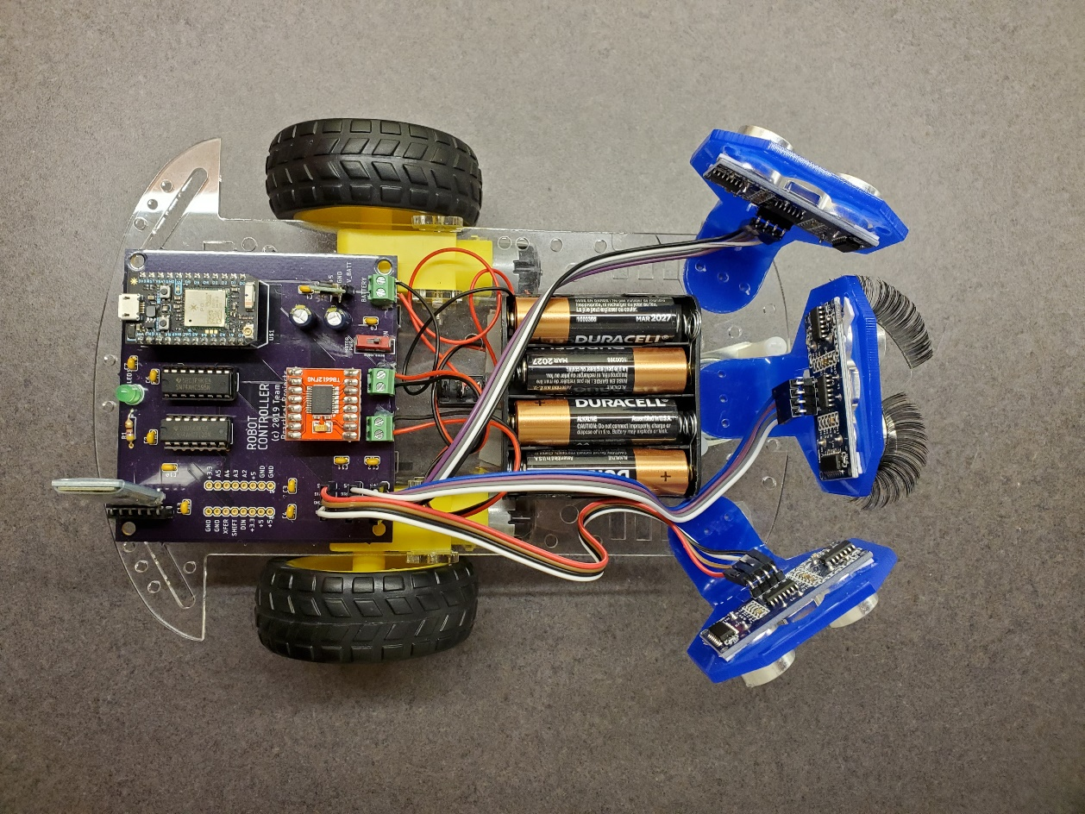

*Figure 3-3. Top View of Wired Robot.*

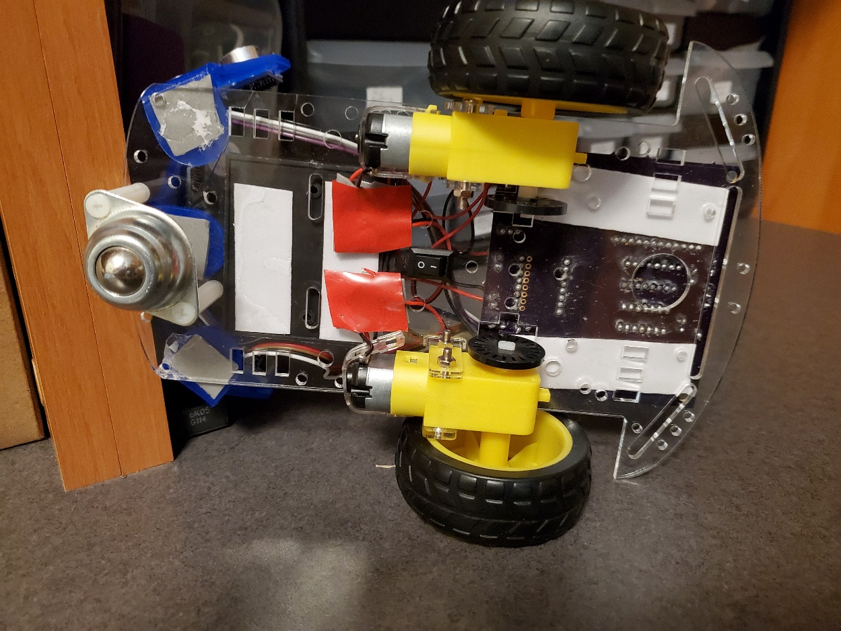

*Figure 3-4. Bottom View of Wired Robot.*

Figure 3-5 shows the wire connections to the Robot PCB.

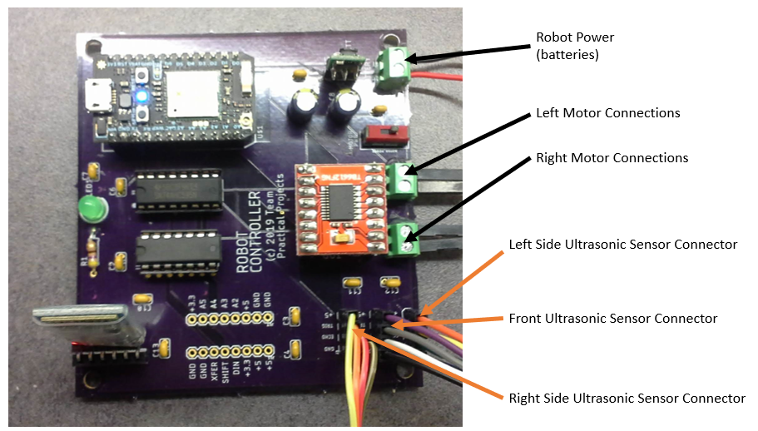

*Figure 3-5. Wire Connections to the Robot PCB.*

Step 1: Battery (Power) wiring. The battery holder has two wires: a red wire and a black wire. The black wire is connected to the “-“ terminal of the BATTERY terminal block on the PCB. The red wire from the battery holder is soldered to the power switch on the chassis (outside terminal). Solder a (red) wire to the center terminal of the power switch and connect the other end of this wire to the “+” terminal of the BATTERY terminal block on the PCB. We suggest trimming these wires back to that they are only a little longer than necessary to make these connections. Make sure that the black and red wires are properly placed into the BATTERY terminal block connections and tighten down the screws on the terminal block to secure these connections.

Step 2: Motor wiring. You should have soldered wires to the left and right motor terminals when assembling the Robot chassis. Use tape or hot glue to fasten these wires to the underside of the Robot chassis in order to provide mechanical strain relief – see figure 3-4. Thread the wires from the left motor through a hole in the chassis to the left of the power switch so that the wires are now available on the top side of the chassis. Wire these to the LEFT MOTOR terminal block. Do the same with the wires from the right side motor, except that the chassis through hole is to the right of the power switch and the wires are connected to the RIGHT MOTOR terminal block on the Robot PCB. *NOTE: the motor wires are not polarized; however, they do determine the direction that the motor spins. We will test this out when the Robot assembly is completed and if one (or both) of the motors spins in the reverse direction that it should, simply reverse that motor’s wires in the terminal block*. Make sure that the wires are properly placed into the terminal block connections and tighten down the screws on the terminal block to secure these connections.

Step 3: Ultrasonic Sensor wiring. You should have three, 4-wire female ribbon cables from the three ultrasonic sensors. The left side sensor is connected to the frontmost (near the terminal blocks) male pin header field. The right side sensor is connected to the rearmost (back from the terminal blocks) male pin header field. The front sensor is connected to the middle male pin header field. You should have noted the color wire from each sensor associated with the Gnd, Echo, Trig and Vcc connections on the sensor. Starting with the left side sensor, plug each female connector of the ribbon cable onto the pin corresponding to that signal on the Robot PCB. After wiring the left side sensor, wire the front sensor next and finally wire the right side sensor. Double check all connections to be sure that they are fully inserted onto the proper male pin.

## Power Up Testing.

Now that your Robot is fully wired, you should test that it powers up correctly. First, make sure that the Robot power switch is turned OFF. Next, install the four AA batteries in the battery holder. Double check that you have set the batteries in the right orientation. Go back and check that you have the Pololu voltage regulator, the motor driver module, the Bluetooth module, the Photon and the ICs plugged into their sockets correctly. Double check that you have the battery “+” (from the power switch) and the battery “-“ leads connected correctly in the BATTERY terminal block. After completing all of the checks, turn the Robot power switch ON. You should see:

* A flashing red light on the Bluetooth module.
* The multicolor LED on the Photon either flashing or “breathing” some color. The behavior depends upon the previous state of the Photon. What is important here is that there is some indication of power to the Photon.

If you do not see these indications, go back and check everything. If necessary, power the Robot off and disconnect all connections to the PCB except for the power connection. Unplug the motor driver module, the Bluetooth module, and the two ICs from the board (leaving only the Pololu voltage regulator and the Photon in place) and power on again. If the Photon powers up, then power off and insert the Bluetooth module and try again. If this works, the plug in the two ICs and try again. If this works, then plug in the motor drive module and try again. If this works, begin reconnecting the motors and the ultrasonic sensors, one at a time to the PCB and keep trying until everything is connected and the PCB is correctly powering up.

If the Photon is new and has not yet been captured to your Particle account, follow Particle’s instructions here:

<https://docs.particle.io/quickstart/photon/>

The Robot is now fully assembled and powers up correctly. The next step is to install the Robot firmware onto the Particle Photon on the Robot PCB.

# FIRMWARE INSTALLATION INSTRUCTIONS.

Firmware is the program (software) that you need to install on your Photon. The firmware for this project is provided in the form of source code. You will need to compile the source code and then “flash” it to your Photon.

Before you can perform any of these steps, you need to get your Photon working on your WiFi network and claimed into your Particle account. If you don’t have a Particle account, you need to create one (it’s free). Particle provides complete documentation for this. Begin at:

<https://docs.particle.io/quickstart/photon/>

You can perform these steps either by removing the Photon from the Robot PCBand powering it directly using a USB cable (as shown in Particle’s on-line documentation) or by performing these steps with the Photon in place in the installed project from section 3. We recommend that, however you do this, you do it in a location with a strong WiFi signal and in a place where you can observe the multi-color LED on the Photon.

If you are not familiar with Particle’s various integrated development environments, you can read up on the Web IDE and the Particle Workbench at:

<https://docs.particle.io/tutorials/developer-tools/build/>

The source file for the firmware for this project can be found at:

<https://github.com/TeamPracticalProjects/Robotics/blob/master/Software/Firmware/AutonomousRobotParticle/src/AutonomousRobotParticle.ino>

This file is in Arduino source code format, which is just plain text and can be edited with any text editor or with either of Particle’s two supported integrated development environments (IDEs). If you are a novice Particle user, we suggest that you use the Web IDE. If you are familiar with the Particle Workbench, you may alternatively use it.

In order to install the Robot firmware on your Photon, you will need to compile and flash the file “AutonomousRobotParticle.ino” onto your Photon There are two ways to do this:

* Use the Particle Web IDE: Open a new project in the Web IDE and delete the default setup() and loop() templates. Open the file “AutonomousRobotParticle.ino” in this repository with any text editor or word processor program[1]. Now copy everything in the program and paste it into the blank template in the Web IDE. Be sure that all lines of “AutonomousRobotParticle.ino” are copied into the Web IDE window and save the program using any name that you wish. Next, use the Web IDE to select your target Photon and flash the code to it. For more information about the Particle Web IDE, see:

<https://docs.particle.io/tutorials/developer-tools/build/>

* Use the Particle Workbench: Copy the folder:

<https://github.com/TeamPracticalProjects/Robotics/tree/master/Software/Firmware/AutonomousRobotParticle>

onto the computer where you are running the Particle Workbench. Use Workbench to compile and flash this code to your Photon. For more information about the Particle Workbench, see:

<https://docs.particle.io/tutorials/developer-tools/workbench/>

The Web IDE approach is probably easier for someone who is new to Particle firmware development, as it is all web based. However, if you plan to develop firmware for Particle devices, we recommend that you install and learn the Workbench.

If you removed the Photon from the Robot PCB, now is the time to unpower it and place it back into the Robot PCB in your project. Power up the project and make sure that the Photon re-connects to the Particle Cloud via WiFi.

NOTE: The Robot firmware places the Photon into “semi-automatic” mode. After flashing this firmware to the Photon, you will need to follow this procedure in order to re-flash firmware to the Photon again:

* Hold down both buttons on the Photon.
* Release the Reset button while continuing to hold down the Setup button.
* After about 3 seconds, release the Setup button.
* The multifunction LED on the Photon should flash green for a little while and then “breathe magenta”. This is “safe mode” and you can now flash new firmware to your Photon. See the Particle documentation for more information:

<https://docs.particle.io/tutorials/device-os/led/photon/>

# ROBOT APP INSTALLATION INSTRUCTIONS.

This project includes an Android app. This App allows the user to control and monitor the Robot. We have provided both source code and an installation file for this App. Source code (in MIT App Inventor 2 source file format) can be found at:

<https://github.com/TeamPracticalProjects/Robotics/blob/master/Software/AI2_app/src/BasicRobotControl.aia>

You need this file only if you want to view and/or modify the app.

The installation file can be found at:

<https://github.com/TeamPracticalProjects/Robotics/blob/master/Software/AI2_app/compiled/BasicRobotControl.apk>

The installation file is called *BasicRobotControl.apk*.

In order to install this app on your Android device, you must transfer this installation file to your device. There are several ways to do this; here are three suggestions:

* Downloading: Download the file *BasicRobotControl.apk* to your Android device using a web browser on the device. Make sure that you know the folder on the Android device where the browser stores downloaded files.
* Sideloading: Download the file *BasicRobotControl.apk*  to your desktop or laptop computer. Attach a USB cable from your desktop/laptop to your Android device. The Android device’s flash memory should appear as a drive on your computer. Drag and drop the installation file to a location on the Android device where you will be able to find it later.
* E-mail: Download the file *BasicRobotControl.apk* to your desktop or laptop computer. Email this file to yourself as an attachment. Open email on your Android device and download the attachment, making sure that you know where the email program/browser stores attachments.

Regardless of the method that you use to get the file *BasicRobotControl.apk* onto your Android device, you now use a file explorer on your device to locate the file and tap on it to start the installation. The App should now install on your Android device. NOTE: you may get a message on your Android device saying that the App is “untrusted” or “unverified”. This means that Android knows that the App did not come from the Google play store. Go ahead and install it anyway – it is safe! The installer will list the permissions that the App needs to run. Go ahead and accept them. The App should install properly.

Once the App is installed on your Android device, tap on its icon to open it. You should see a screen similar to figure 6-1.

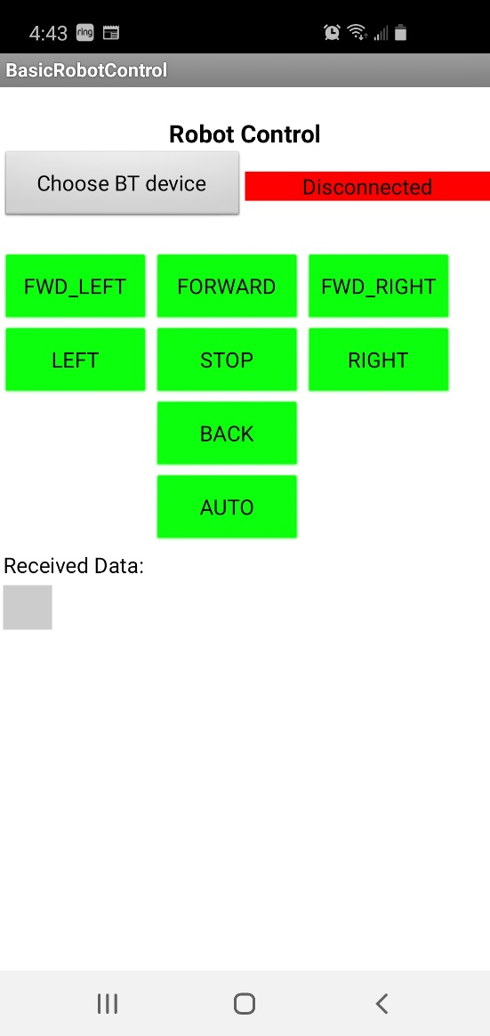

*Figure 6-1. App Main Screen.*

You are now ready to operate your Robot. Refer to the User manual “Robot_User_Manual.pdf” for instructions about operating your Robot:

1. When using a word processing program for this purpose, be sure that it is in plain text mode.